1. Write a C++ program that demonstrates member function eof and get on input stream cin and member function put on output stream cout. This program uses get to read characters into the int variable character, so that we can test each character entered to see if it’s EOF. The program first prints the value of cin.eof() (i.e. false, 0 on the output) to show that end-of-file has not occurred on cin.

**Sample Run:**

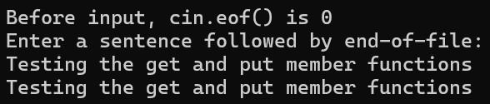

1. Inputting characters using the cin member function getline.

Create an array of 80 characters. Input characters in buffer via cin function getline.

**Sample Run:**

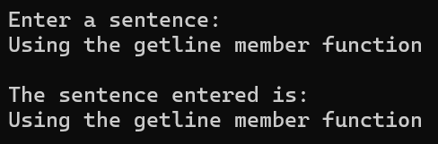

1. Write a C++ program that includes ***Exception Handling***, by using the try, throw, and catch algorithm.

Create a class called **Negative** that controls the number of trucks and returns a message to the user.

* + Declare the message as a private member. (string)
  + Use member initialization while declaring your class constructor.
  + Use function getMessage() for returning your message.

Create another class named as **ZeroDivision** that has no members and it is created for using the throw and catch part of your main function.

In your program, you would like to calculate load per truck. Any negative number of weight and/or truck would be illogical. Similarly, a zero number of trucks should warn the user.

In the main function,

* + Declare load and truck variables that are both countable assets of your program. (int)
  + Declare loadPerTruck that controls the loaded truck of your program. (double)
  + You have to check the number of loads of packages and trucks.

Negative number mistake and the truck availability has to be controlled and you have to use cerr for your output.

**Sample Run 1:**

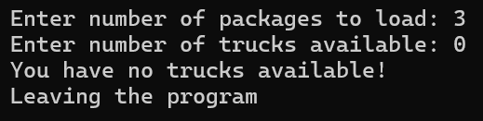

**Sample Run 2:**

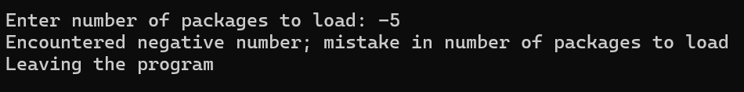

**Sample Run 3:**

